1. Creating and Renaming Files/Directories

1.Create a directory named test_dir using mkdir.

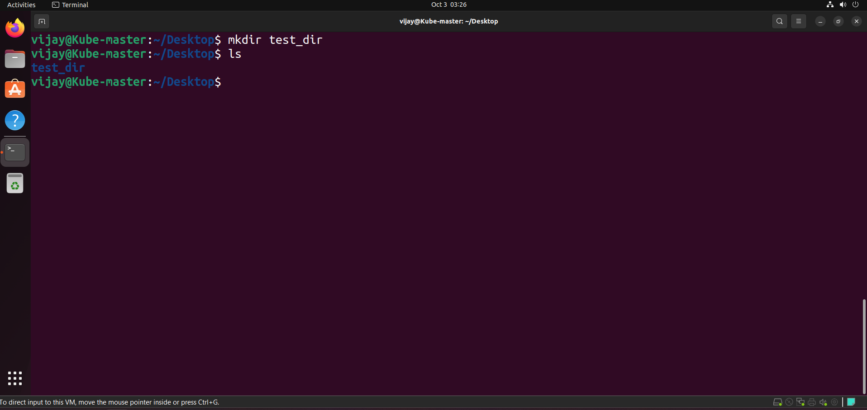

The mkdir command (make directory) is used to create a new directory.

2.Inside test_dir, create an empty file called example.txt. 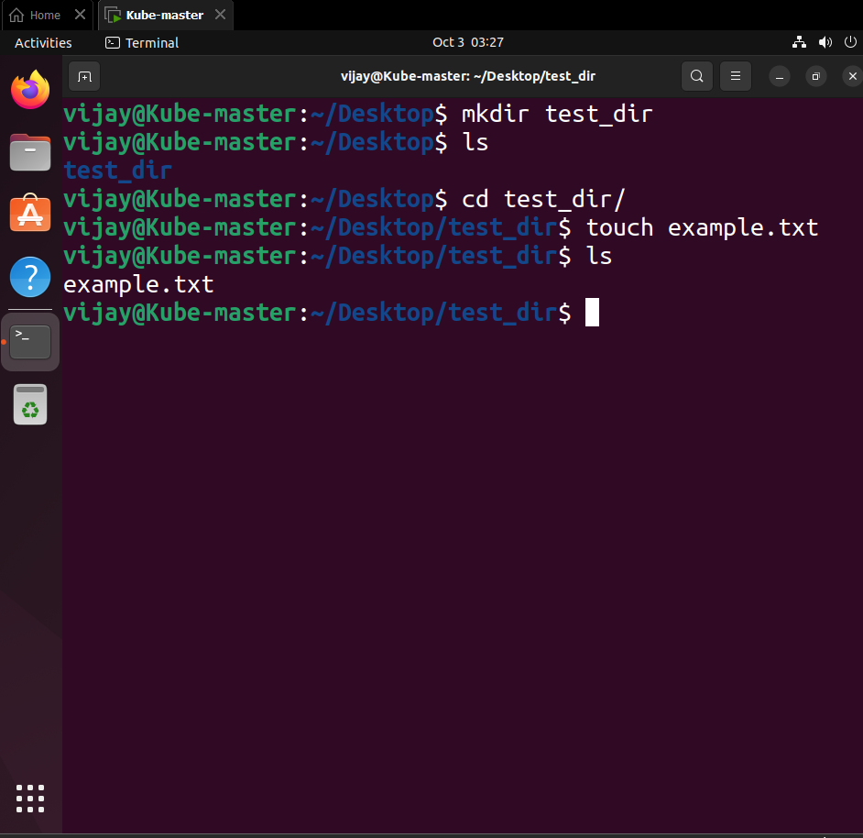

The touch command updates the timestamp of a file; if the file doesn't exist, it creates an empty one. We specify the path to create it inside test_dir.

3.Rename example.txt to renamed_example.txt using mv

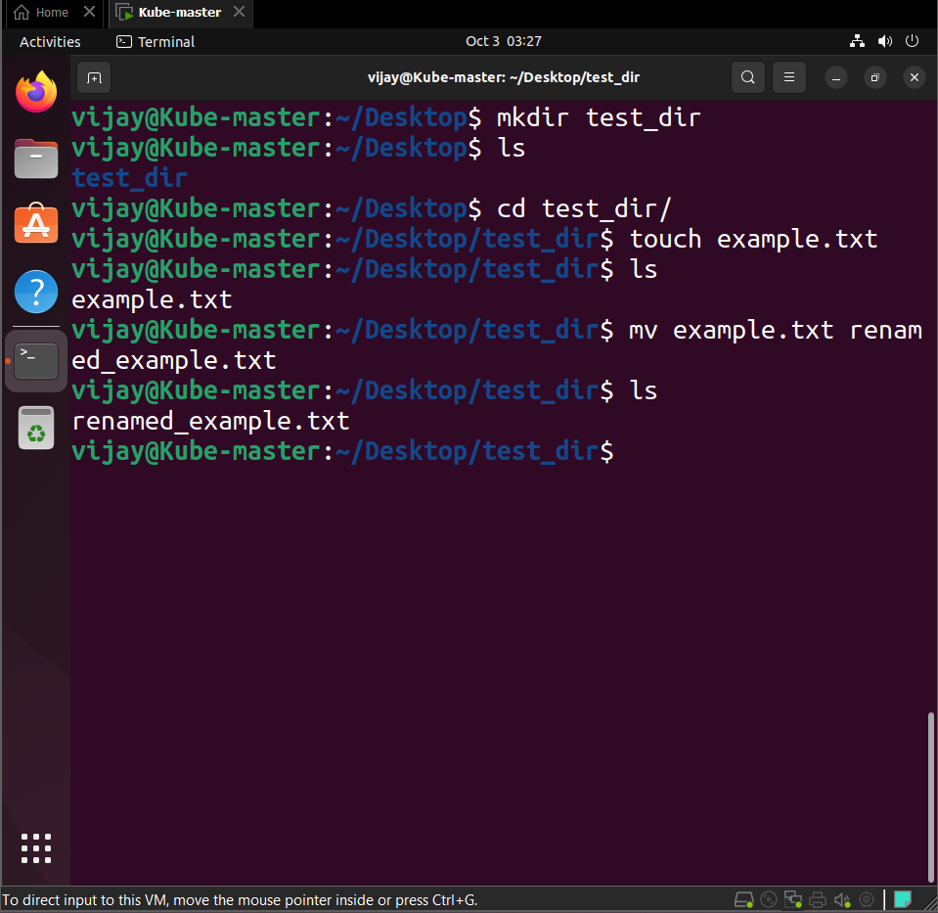

The mv command (move) is used to rename files or directories, or to move them between directories. The syntax is mv [source] [destination].

2. Viewing File Contents

1.Use cat to display the contents of /etc/passwd.

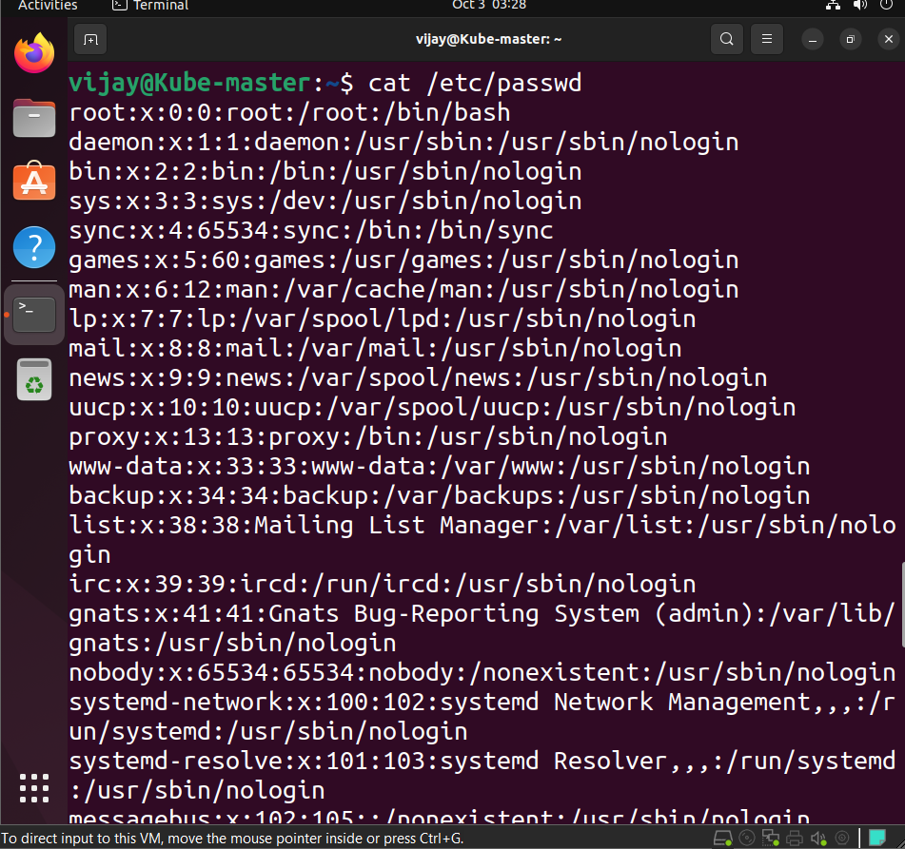

The cat command (concatenate) reads file contents sequentially and writes them to standard output.

2.Display only the first 5 lines of /etc/passwd using head.

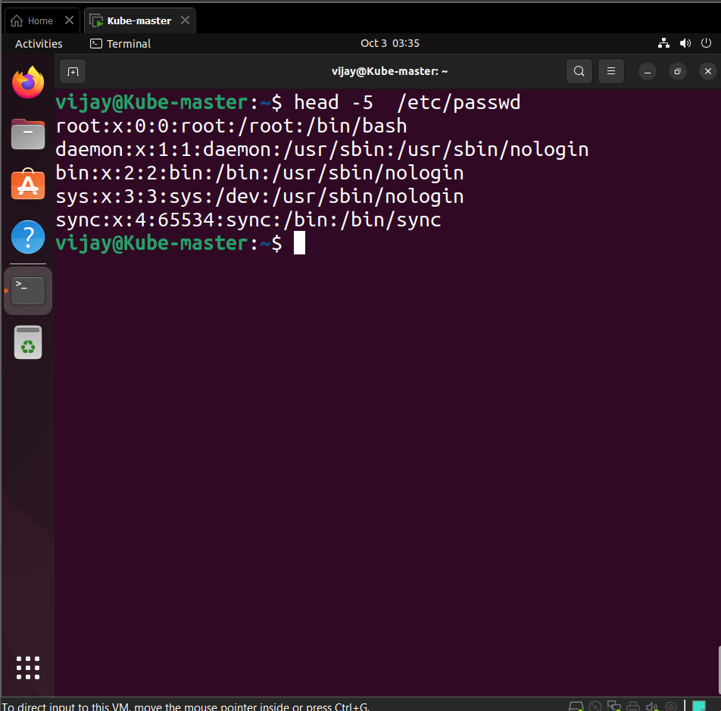

The head command outputs the beginning of a file. The -5 option specifies that only the first 5 lines should be displayed.

3.Display only the last 5 lines of /etc/passwd using tail.

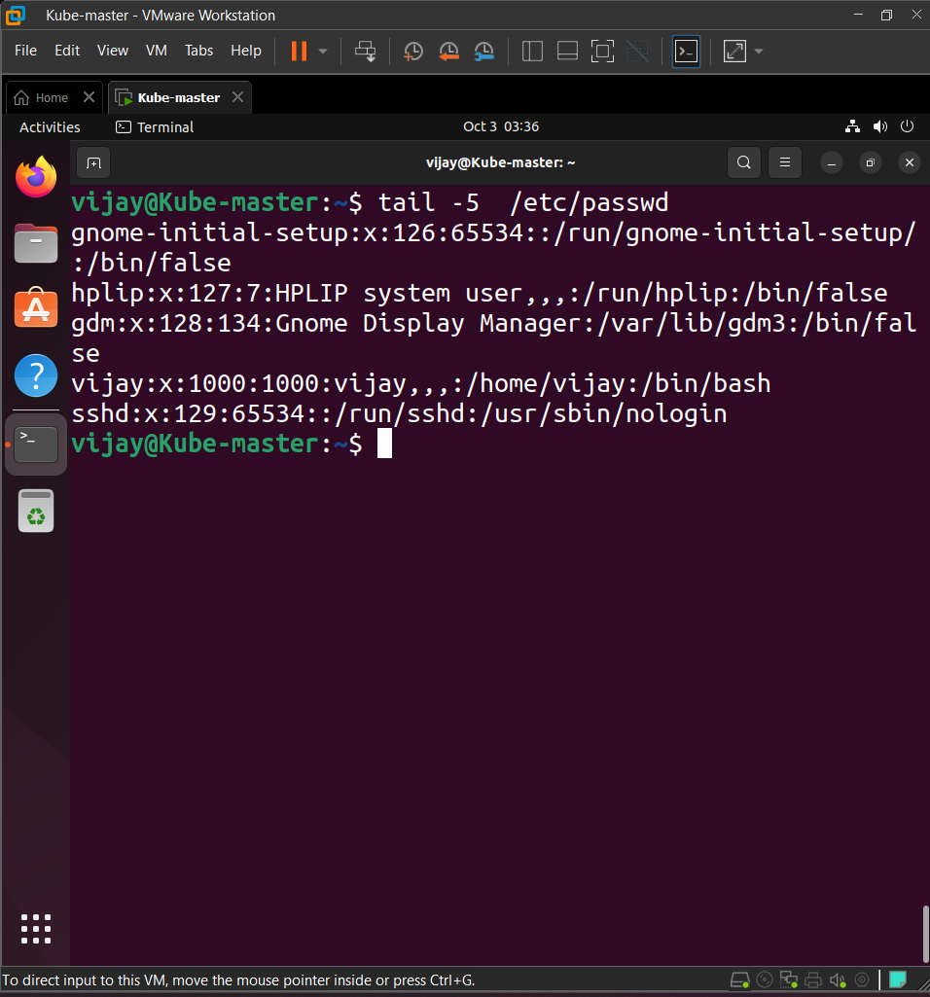

| The tail command outputs the last part of a file. The -5 option specifies that only the last 5 lines should be displayed. |
| --- |

3.Searching for Patterns

1.Use grep to find all lines containing the word "root" in /etc/passwd.

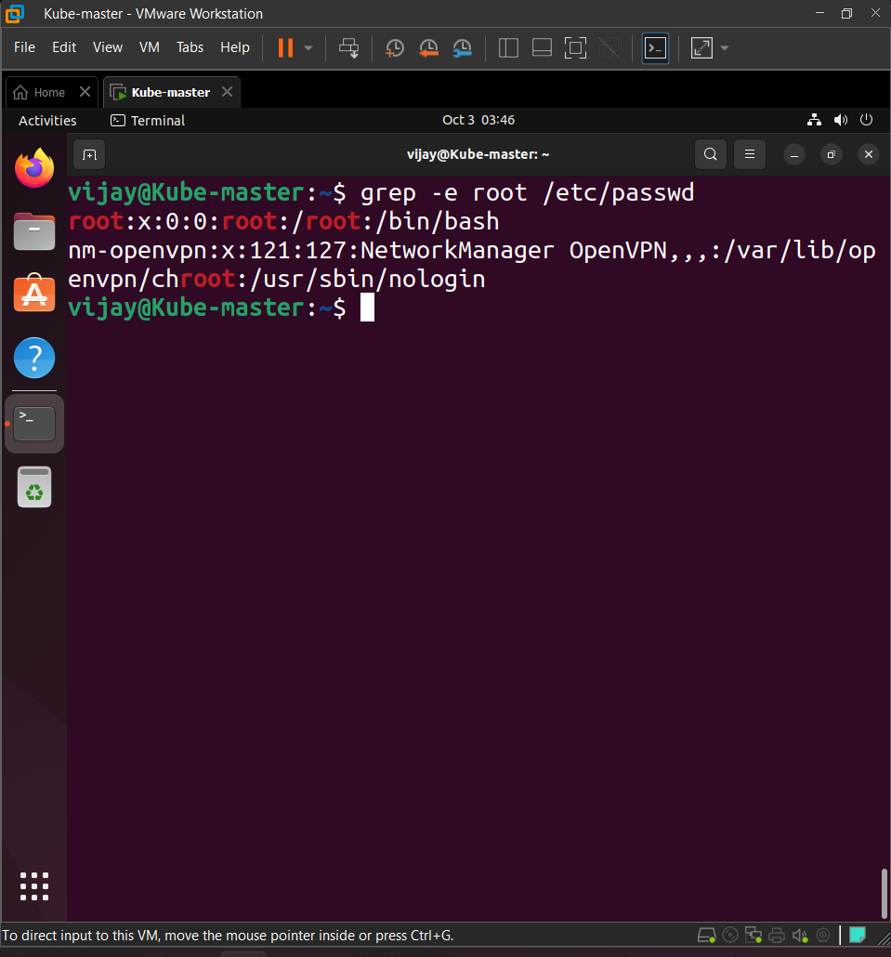

| The grep command searches for lines matching a specified pattern (the search term, in this case, "root") in the given files. |
| --- |

4. Zipping and Unzipping

1.Compress the test_dir directory into a file named test_dir.zip using zip.

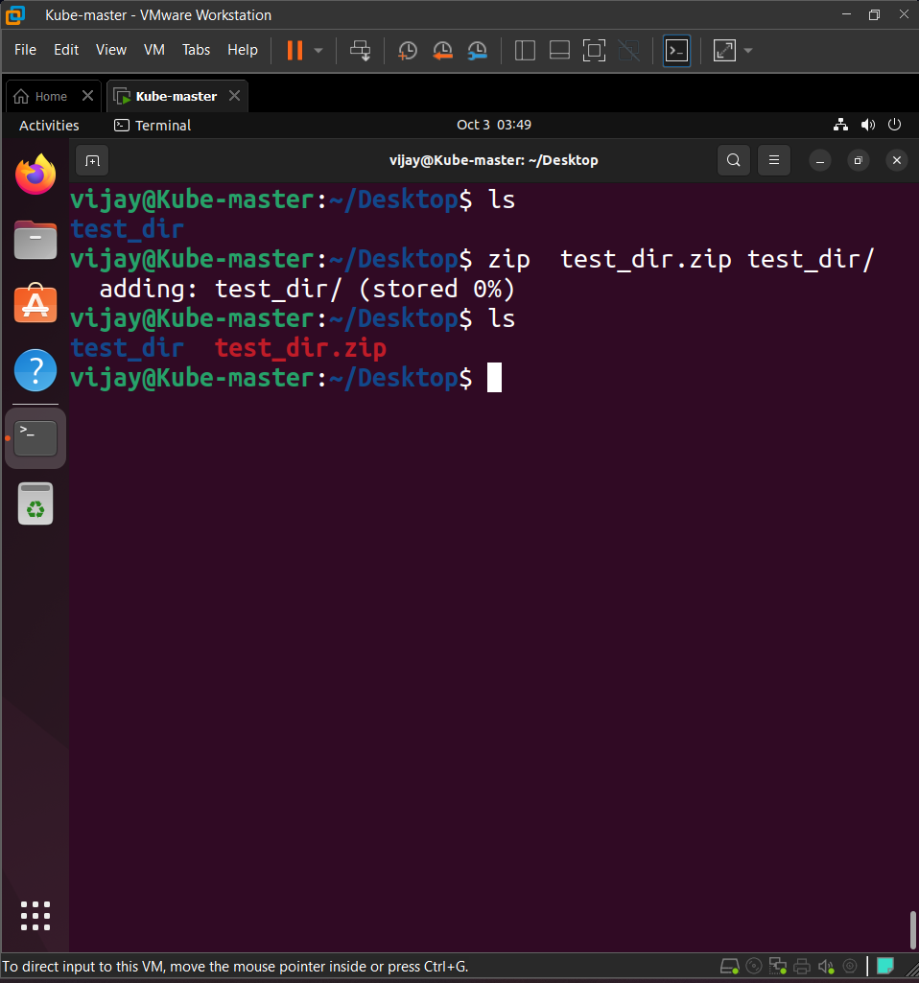

The zip command creates a zip archive. The **-r** (recursive) option is necessary to include the contents of a directory.

2.Unzip test_dir.zip into a new directory named unzipped_dir.

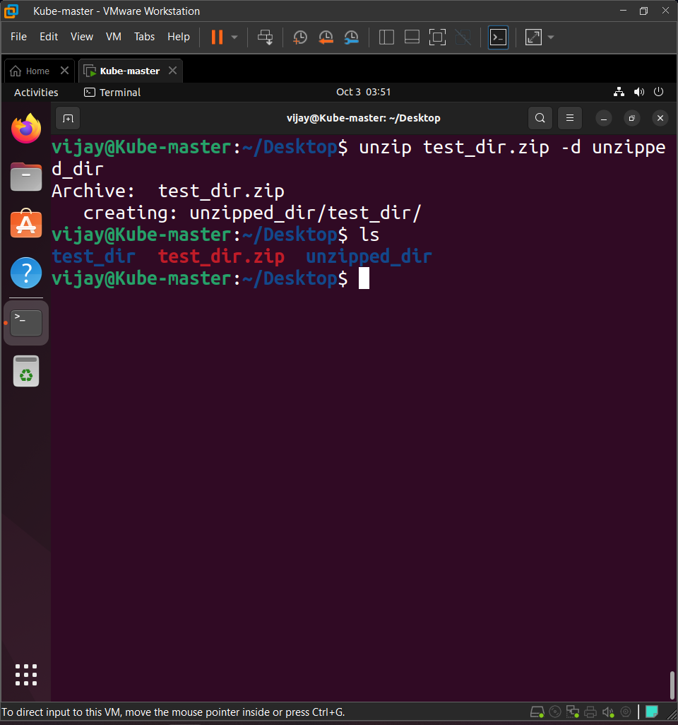

| The unzip command extracts files from a zip archive. The **-d** (directory) option specifies the target directory for the extraction. |
| --- |

5. Downloading Files

1.Use wget to download a file from a URL (e.g., <https://example.com/sample.txt>).

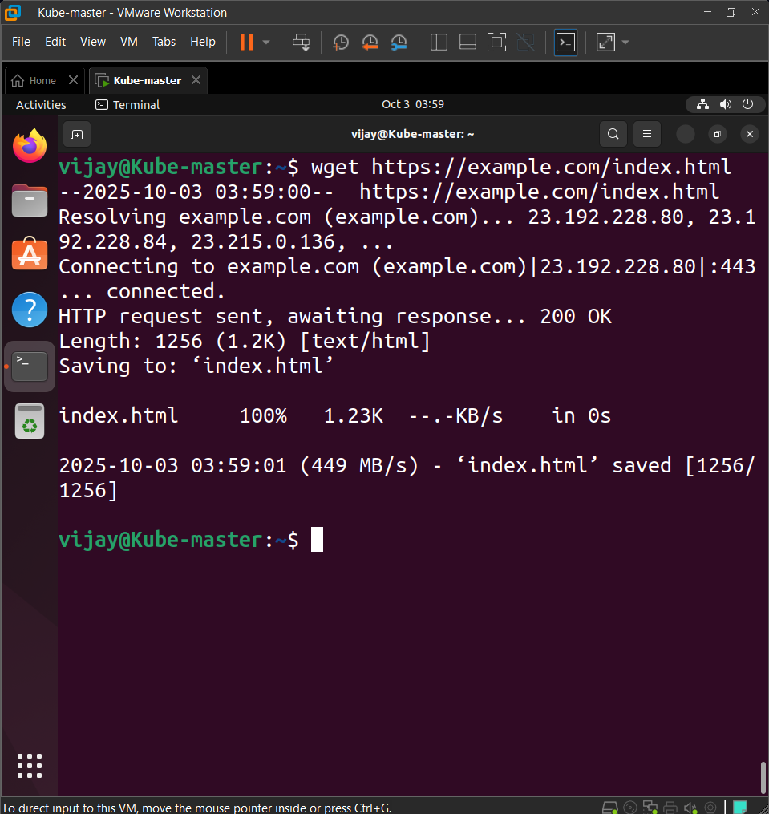

| The wget command retrieves content from web servers. I've used https://example.com/index.html as a reliable sample URL. |
| --- |

6. Changing Permissions

1.Create a file named secure.txt and change its permissions to read-only for everyone using chmod.

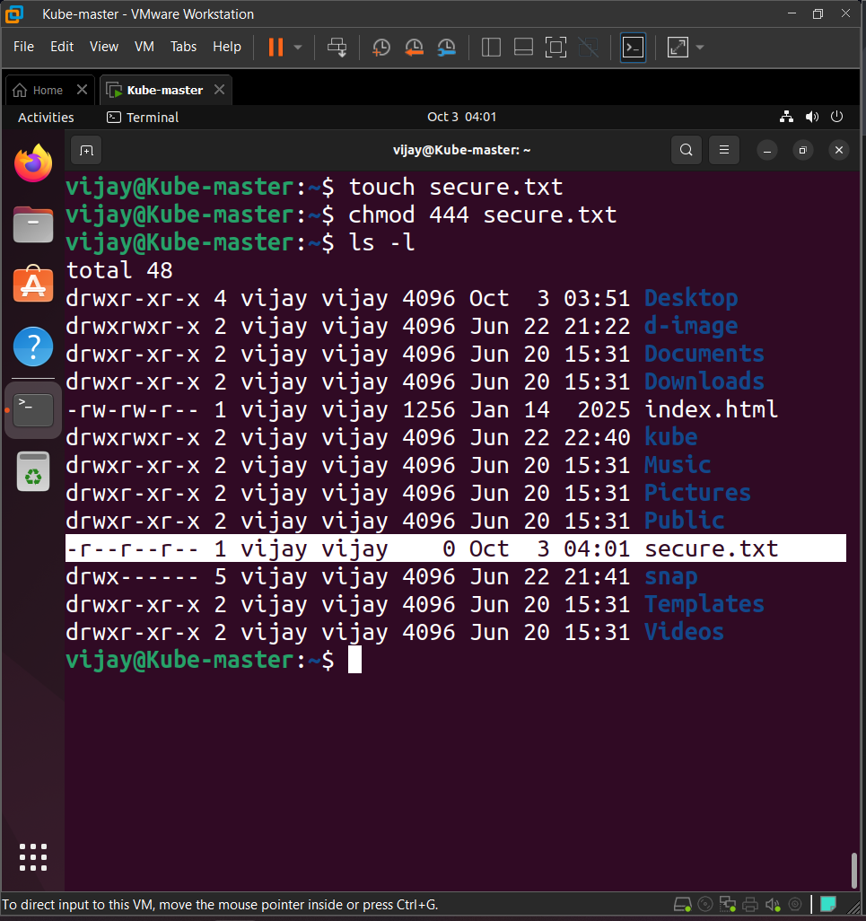

Creates the file.

The chmod command changes the file mode bits (permissions). The **444** numeric mode grants **read-only** permission to the **Owner (4)**, **Group (4)**, and **Others (4)**, and removes write/execute access.

7. Working with Environment Variables

1.Use export to set a new environment variable called MY_VAR with the value "Hello, Linux!".

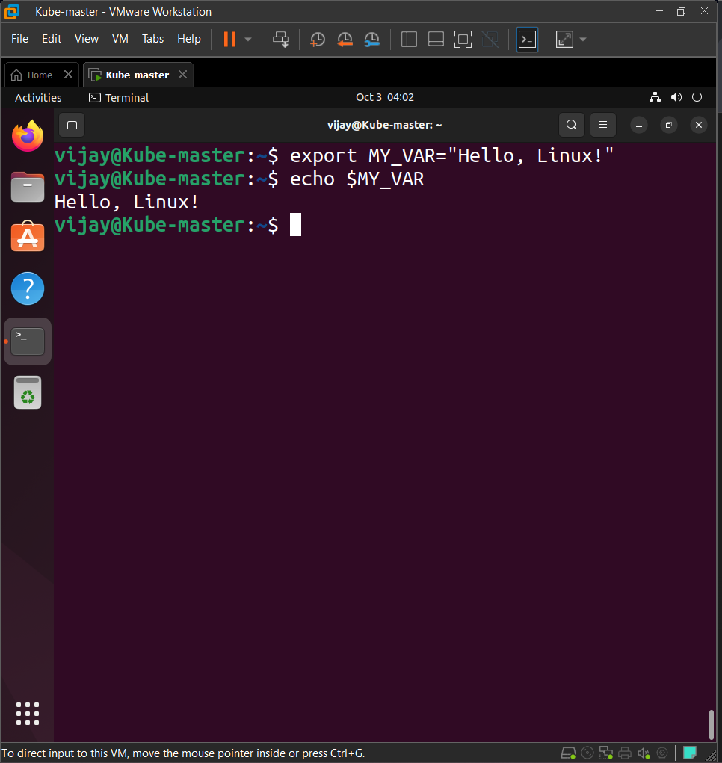

The export command marks an environment variable to be passed to child processes. The variable name is set, followed by an equals sign and its value (enclosed in quotes is best practice, especially if the value contains spaces).